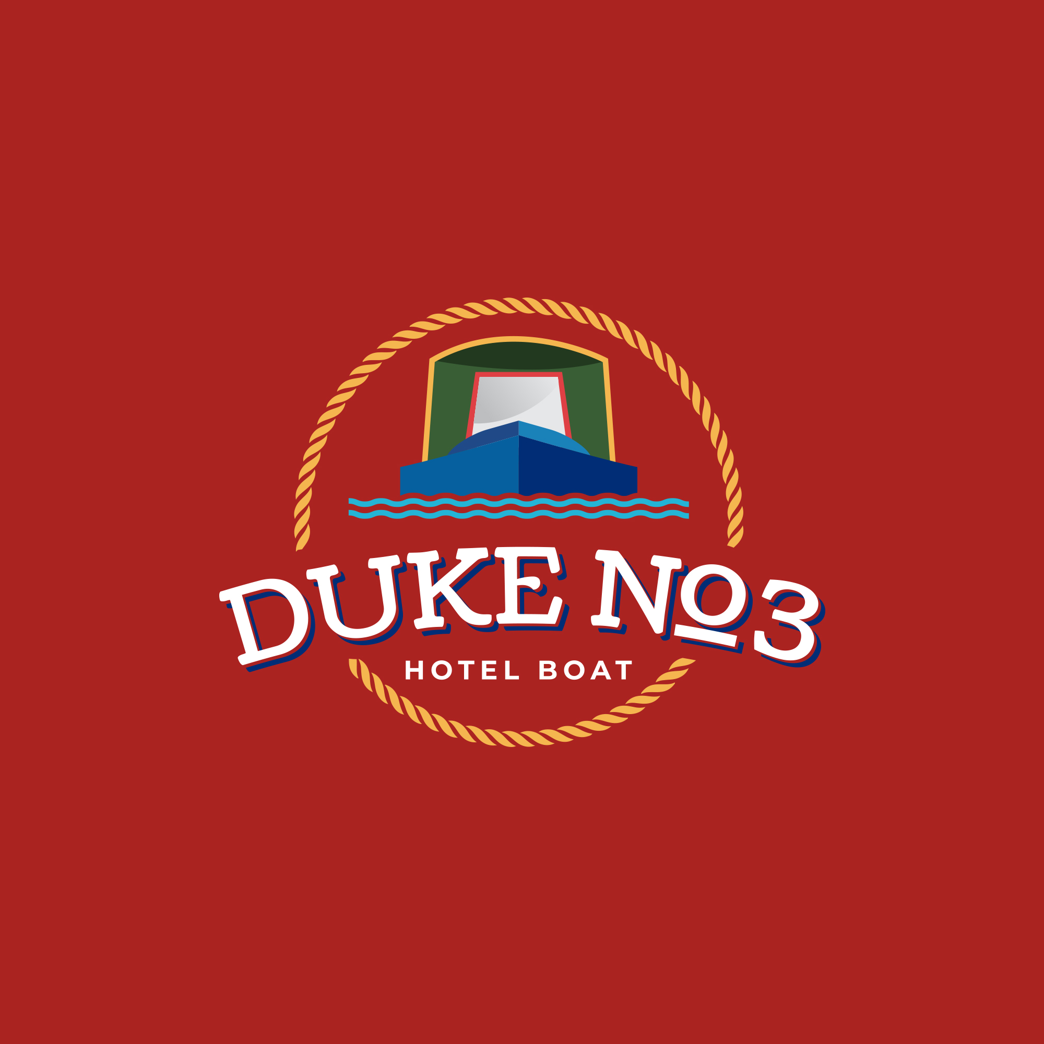
Hotel Narrowboats Ltd
53 Penylan Road
BLACKWOOD
Gwent
NP12 0AY

Tel: 07376 471154
Email: info@hotel-narrowboats.co.uk

Dear Guest,

We look forward to welcoming you on board Duke No3 soon.

Following a successful 2025 season, we are pleased to announce that 2026 is fully booked. We appreciate your continued trust in us for your holiday. While the hotel boating industry is seeing fewer operators, we remain committed to our short-season format for the foreseeable future.

The incident on the Llangollen Canal late last year highlights the challenges within the canal network. We appreciate our guests' understanding when we must alter itineraries due to such events.

Duke No3 is currently undergoing winter maintenance, including several guest-suggested updates. We are also happy to announce that both Henry and Taff will return this season. You can continue to expect our signature homemade meals and open bar. We pride ourselves on providing exceptional value on the network.

Enclosed is an information pack regarding your upcoming cruise. Please review and return the following documents at your convenience:

- Final Invoice: Due eight weeks prior to your cruise.
- Guest Information Document: General details and FAQs.
- Pickup and Drop-off Locations: Our proposed moorings.
- Medical and Emergency Contact Form: One required per guest.
- Dietary Requirements Form: One required per guest.

All provided information is held in strict confidence and will be destroyed following your departure.

Thank you for choosing to cruise with us. Henry, Taff, and I look forward to seeing you on board.

Regards,

Neil.

