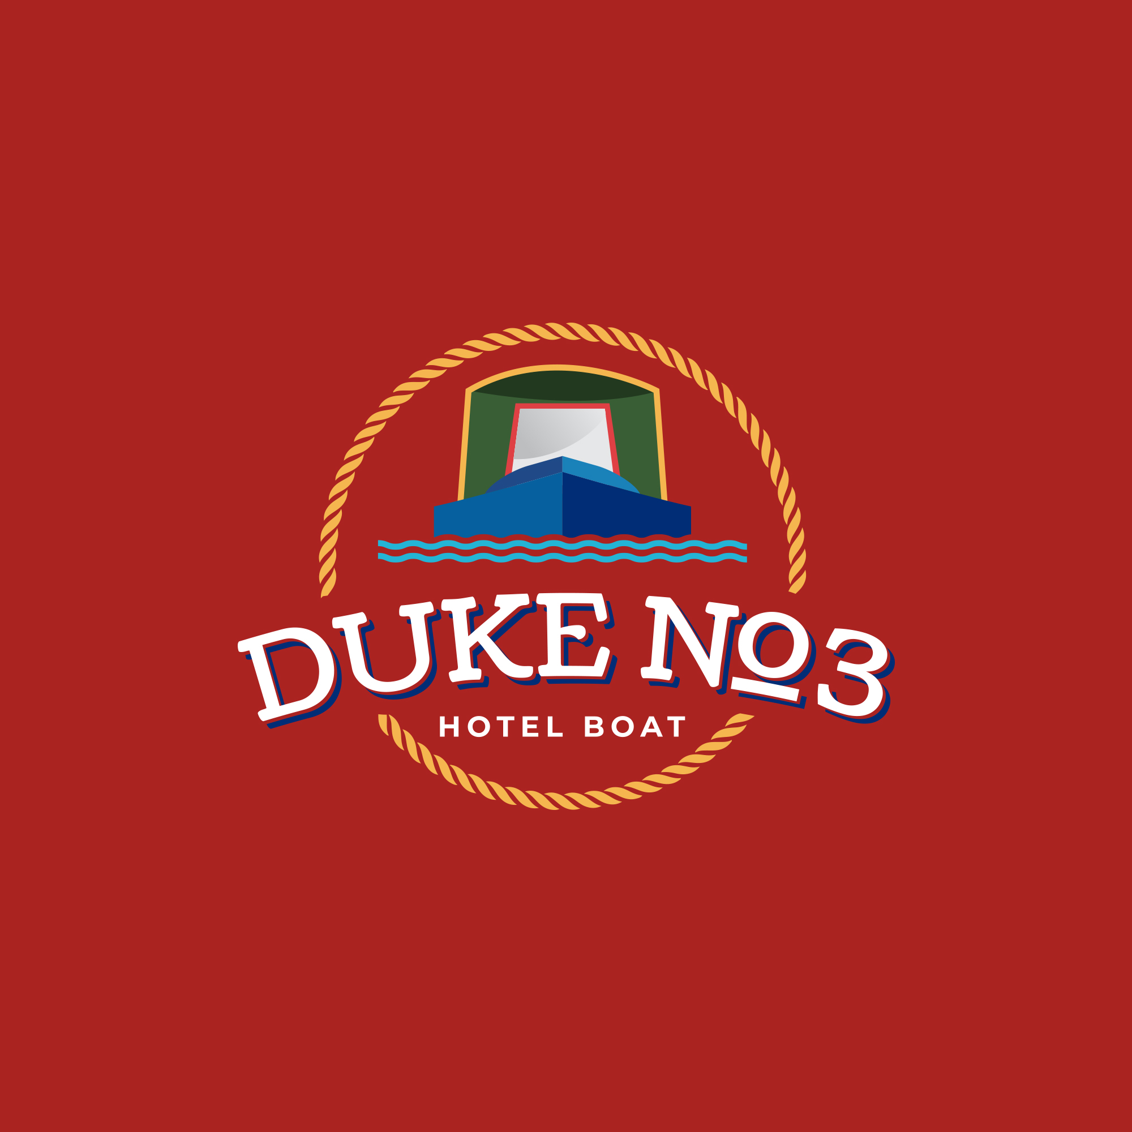
Hotel Narrowboats Ltd
53 Penylan Road
BLACKWOOD
Gwent
NP12 0AY

Tel: 07376 471154
Email: info@hotel-narrowboats.co.uk

Dear Guest,

We look forward to welcoming you on board Duke No3 soon.

Following a successful 2025 season, we are pleased to announce that 2026 is fully booked. We appreciate your continued trust in us for your holiday. While the hotel boating industry is seeing fewer operators, we remain committed to our short-season format for the foreseeable future.

The incident on the Llangollen Canal late last year highlights the challenges within the canal network, and we appreciate your understanding when we must alter itineraries due to such events.

Duke No3 is currently undergoing winter maintenance, including several guest-suggested updates. We are also happy to announce that both Henry and Taff will return this season. You can continue to expect our signature homemade meals and open bar as we pride ourselves on providing exceptional value on the network.

Please visit our website to find all the information regarding your upcoming cruise. We ask that you review and complete the following documents at your convenience. You will find:

- Final Invoice: Sent individually and due eight weeks prior to your cruise.
- Guest Information Document: General details and FAQs.
- Pickup and Drop-off Locations: Our proposed moorings.
- Dietary, Medical, and Emergency Contact Form: Required for each guest.

All provided information is held in strict confidence and will be destroyed following your departure.

Thank you for choosing to cruise with us. Henry, Taff, and I look forward to seeing you on board.

Regards,

Neil

