Hotel Narrowboats Ltd  53 Penylan Road, Argoed, Blackwood, NP12 0AY  Registered No. 08711191 VAT Reg No. 178 0892 68 | 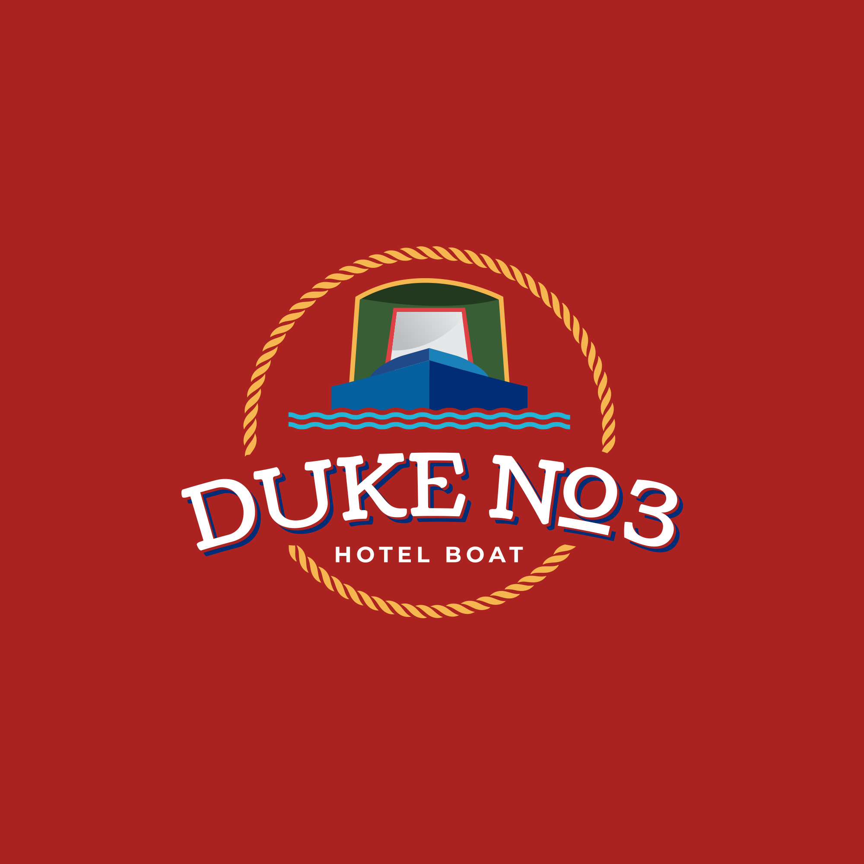
e

Booking Form 2023
Cruise date or
number:

Name:

Address:

Telephone:

Email address:

Date of birth:

Name(s) DofB(s)
of others in party:

Accommodation Twin/Double en-suite Configured: Twin or Double
requirements
(circle) Single en-suite Single en-suite
Deposit: £200 per person per week

Paying by cheque: Cheques payable to: Hotel Narrowboats Ltd

Paying by bank Transfer: Account name: Hotel Narrowboats Ltd
Account number: 03694445 Sort Code: 20-53-77
(International add SWIFTBAC: BARCGB22
£10.00 per transaction) IBAN: GB95 BARC 2053 7703 6944 45

Paying by debit/credit Card payment can be made by calling +44 (0) 7376 471154

There is a 2.5% surcharge for all Non-UK debit/credit card holders.

I have read and agree to the terms and conditions of booking (on reverse)
I/we have cancellation insurance (strongly recommended)

Signed: Date:

Tel: 07376 471154 Email: info@hotel-narrowboats.co.uk Web: www.hotel-narrowboats.co.uk

Terms and Conditions of Booking

In these conditions, governed and interpreted according to the rules of English law, THE COMPANY referred to is Hotel Narrowboats Ltd.

BOOKINGS, DEPOSITS AND OUTSTANDING BALANCE: We, the Company can provisionally reserve cabins for you by telephone or email but bookings can only be confirmed on receipt of a properly completed Booking Form and the appropriate deposit of £200 per person per cruise. The Booking Form and our acknowledgement constitute a legally binding contract between you and the Company. We will be legally bound to provide the accommodation as booked. You, in turn will be legally bound to pay the balance of the cost, which must be paid at least 8 weeks before the start of the holiday. Bookings may not be transferred to a third party without the permission of the Company. We reserve the right to request details of cancellation insurance for full boat charters.

OPERATORS RIGHT OF TERMINATION: We, the Company reserve the right to decline a booking without assigning any reason for so doing. We reserve the right to terminate a passenger’s cruise, should the person, in our opinion, have placed themselves, other passengers, the boats or equipment in danger of injury or damage by ignoring safety advice or instructions of the crew. We also reserve the right to terminate the cruise of any passenger found smoking inside the boats, or who, in the opinion of the skipper of the boats behaves in a manner disruptive to the other passengers. Any refund of the price of the holiday would be paid entirely at the discretion of the Company. We reserve the right to cancel any cruise for which there are insufficient bookings, or if due to circumstances beyond our control, it has become impossible to carry out the cruise. In such cases, you will, if possible, be offered alternative dates. Otherwise, any sum received from you will be returned in full but you shall make no claim on any account against us. The Company reserves the right end the contract with reasonable notice and agrees to return in full any deposit and payments and you shall have no further claim on any account against us.

WATER RESTRICTIONS & FORCE MAJEURE: We, the Company reserve the right to alter or amend a published cruise route (or routes) if this is made necessary by canal stoppages, water shortages, flood, or if we deem this to be in the best interest of our passengers and crew. We reserve the right to re-allocate accommodation when, in our opinion, it is necessary to do so. You will have no claim on us and no particular right of cancellation should any re-routing be necessary. Whilst we make every effort to keep to the advertised timetables, we shall not be liable for any loss caused to you by delay, mechanical or electrical breakdown, failure to keep to time or any cause whatsoever. Should navigational difficulties prevail on the waterway, the cruise may be re-scheduled to commence, divert or terminate at alternative locations or on an alternative craft in order to safeguard the holiday. This situation will not be considered grounds for cancellation of a confirmed holiday.

PERSONAL ACCIDENT & GUESTS PROPERTY: We, the Company shall not be liable for any loss or damage to any article or personal property belonging to you which may be sustained during the cruise or whilst the articles are upon the boats or premises or vehicles belonging to us. Except in respect of death or personal injury caused by our negligence, we shall not be liable for any personal injury suffered by you during the cruise or whilst upon the boats or premises or vehicles belonging to us. If we advise car parking facilities, we shall not be liable for any loss or damage to your vehicle or its contents. We are unable to arrange car parking facilities, where we advise facilities, it is your responsibility to contact the facility direct to arrange to park. We can take no responsibility for the consequences of not being informed in writing of your dietary requirements, food dislikes or any relevant health problems.

GENERAL: No children under 14 will be carried, except as part of a whole boat charter when additional booking conditions may apply. Smoking is not permitted inside the boats or well-decks. We reserve the right to levy a surcharge should our VAT rating or the rate of VAT change after your booking is made. Whilst every effort is made to ensure the accuracy of the contents of our website and other publicity materials, we shall not be liable for any inaccuracies that may occur.

