Stourbridge

1. Proposed Moorings (Nearest Location to the canal):

2 Canal St, Amblecote, Stourbridge DY8 4LU

2. Nearest Train Stations:

Stourbridge Junction – 1.2 mile

Timetable information – www.nationalrail.co.uk
Purchase train tickets – www.thetrainline.com or www.splitticketing.com

3. Taxi Service:

Crystal Cabs: 01384422888

4. Parking:

Birmingham Street Car Park (www.parkopedia.co.uk)

Birmingham Street, Dudley, DY8 1 JG

5. Map:

The arrow indicates our approximate moorings, if it is not possible to moor as indicated we will be as near to this location as possible.

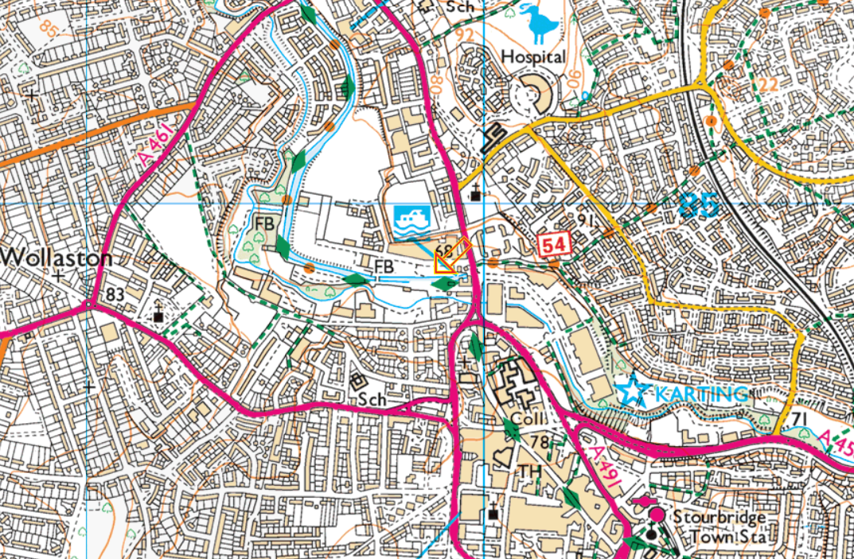
r

