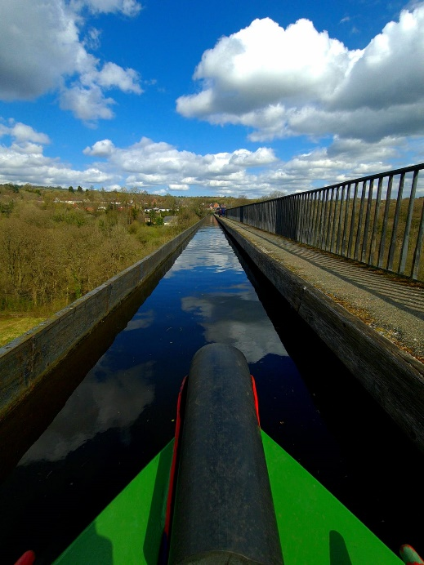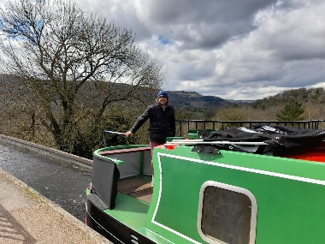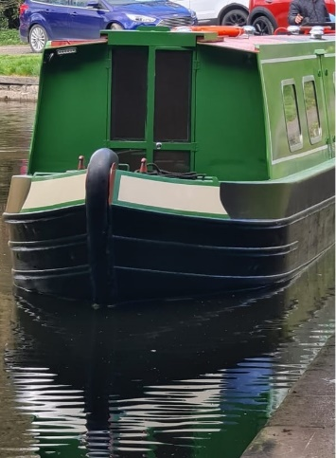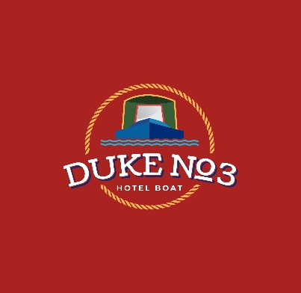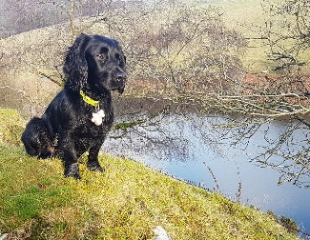/

Come join myself, Henry my dog and the crew aboard the Duke No3 for an all inclusive cruise exploring Britain’s Inland Wateways. The Duke No3 is a 70-foot narrowboat hosting upto 4 guests in fully en-suite cabins. We take in some of the countries most gorgeous countryside and vibrant cities on our cruises. Please take a moment to view the website to find more about: the boat, our planned routes and how to book. Find us on Facebook too.

Best wishes,

**Neil (and Henry), owner of the Duke & Duchess**

All-inclusive cruises touring the inland waterways on board a 70-foot hotel narrowboat.

07376 471154

www.hotel-narrowboats.co.uk

**duke No3**

**Hotel Boat**

HOTel narrowboats ltd

53 Penylan Road, BLACKWOOD, Gwent, NP12 0AY

07376 471154

[www.hotel-narrowboats.co.uk](http://www.hotel-narrowboats.co.uk)

info@hotel-narrowboats.co.uk

**@hotelnarrowboats**

Welcome Aboard

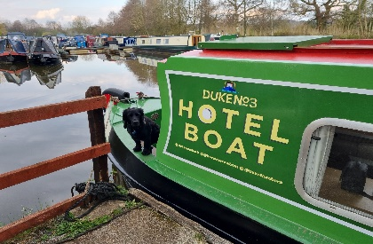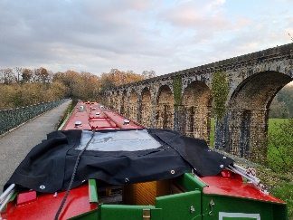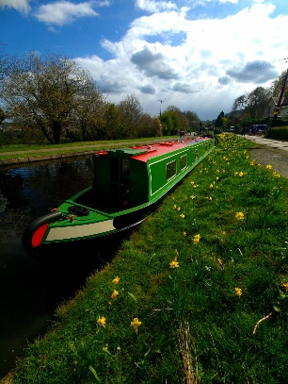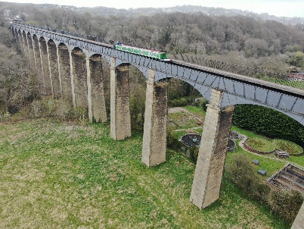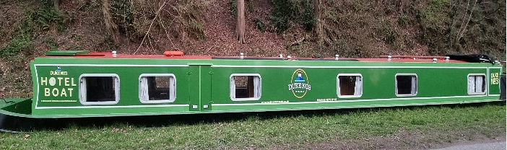

**All inclusive?**

All meals are provided and cooked fresh, which are prepared with fresh ingredients; house wine is provided at dinner and Port or Brandy with the cheese course. Tea and coffee, with biscuits or home-made cakes are served mid morning and afternoon. We can cater for all diets.

Your morning will start with breakfast freshley prepared and served in the lounge. With a range of options from a full English breakfast, yoghurt or a bowl of cerial, we will aim to cater for your every need.

During breakfast the crew will be cleaning your cabin, making the beds and preparing the boat for the day ahead. After breakfast you will receive a brief of the day’s planned route and cruising will begin around 9am.

Morning tea, coffee and biscuits will be served around 11am and we will stop for lunch at 12:30pm. Lunch will be light, options which may include items such as omlette and salad. We continue cruising into the afternoon when homemade cakes with tea and coffee are served. We look to moor up around 5pm which gives you time to explore, have a rest or visit a canal side pub before evening meal at 6.00pm.

Dinner is 4 courses, including a cheese course, complementary house wine is provided during your meal. Port Whisky and Brandy is offered with your cheese course.

Everything in-between is up to you…. Relax, take part but mostly enjoy the adventure.

**Want to relax?**

If so, then this trip is perfect. Let the crew take care of your every need. Do as much or as little as you like.

**Pets?**

Henry, the friendly Working Cocker will be on board but sadly no other pets are permitted.

**Medical needs?**

If you have any concerns please get in contact. We will act in a confidential manner and we will be able to confirm if this holiday is suitable for yourself.

**Discounts?**

Discounts are given to returning guests and military (inc veterans)

**Travelling alone?**

Don’t worry, many guests arrive solo but friendships are quickly made, nobody’s a stranger for long.

A typical day, although no two days are the same.

**A special occasion?**

Let us know when you book and we will ensure to make the occasion extra special.

**Safety?**

All the crew hold first aid, food hygiene and/or helmsman qualifications. Life jackets are available for your safety.

When you join us on board you will be made welcome and looked after until the moment you leave. This is your holiday so take it at your pace. Do as much or as little as you like; walk the towpath, read a book, help with the locks or simply sit in the well deck and watch nature pass you by.

**Can I get involved?**

Yes, please help the crew with the locks and bridges. Instructions will be given and assistance will be on hand.

Holidays to suit all