Coventry

1. Proposed Moorings (Nearest Location to the canal):

Coventry Canal Basin, St Nicholas St, Coventry CV1 4LY

2. Nearest Train Stations:

Coventry Station – 1 mile

Timetable information – www.nationalrail.co.uk
Purchase train tickets – www.thetrainline.com or www.splitticketing.com

3. Taxi Service:

Taxi Coventry – 02477 620620

4. Parking:

NCP, Silver Street, 29 Silver Street, Coventry, CV1 1AR - https://www.ncp.co.uk/find-a-car-park/car-parks/coventry-silver-street/

5. Map:

The arrow indicates our approximate moorings, if it is not possible to moor as indicated we will be as near to this location as possible.

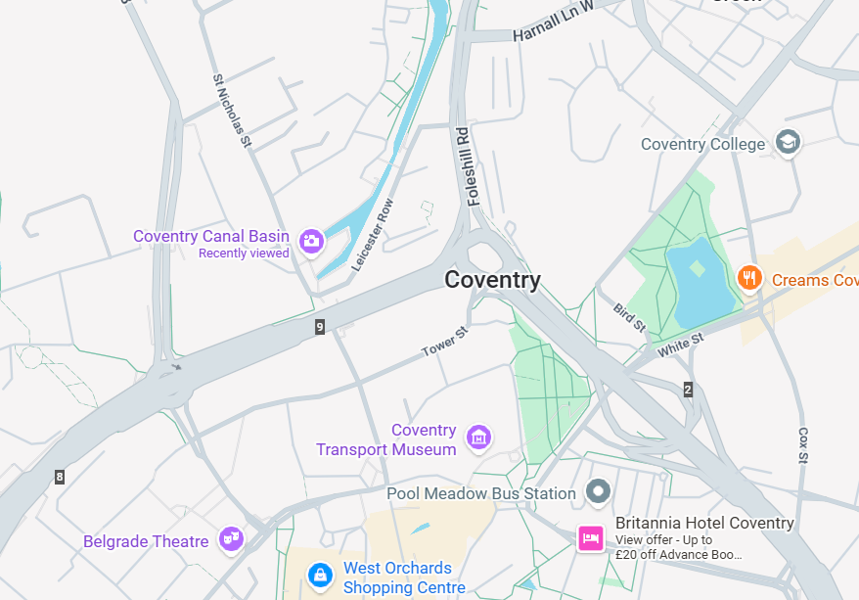
r

