Paddington

1. Proposed Moorings (Nearest Location to the canal):

Hermitage St, London W2 1BE

2. Nearest Train Stations:

Paddington Station – 0.1 mile

Timetable information – www.nationalrail.co.uk
Purchase train tickets – www.thetrainline.com or www.splitticketing.com

3. Taxi Service:

Black Cabs
UBER - yes

4. Parking:

Good luck wishing to park in London I’d suggest you DO NOT consider this. However if you would prefer then the following link will assist: www.parkopedia.co.uk

5. Map:

The arrow indicates our approximate moorings, if it is not possible to moor as indicated we will be as near to this location as possible.

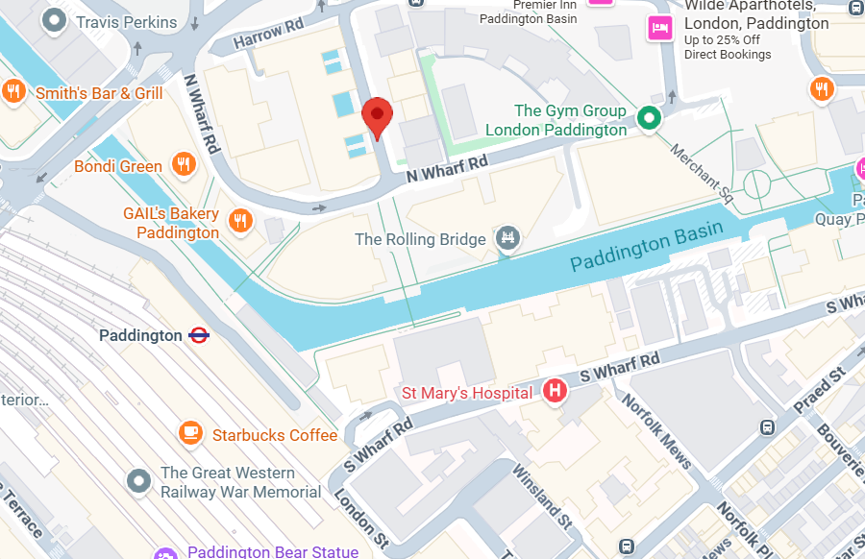
r

