Oxford

1. Proposed Moorings (Nearest Location to the canal):

23 Canal St, Oxford OX2 6BH – Other side of canal to this address.

2. Nearest Train Stations:

Oxford – 0.5 mile

Timetable information – www.nationalrail.co.uk
Purchase train tickets – www.thetrainline.com or www.splitticketing.com

3. Taxi Service:

A2b Oxford Taxi – 01865477477
UBER - Yes

4. Parking:

Long stay car parking is difficult. If required the following website will assist: www.parkopedia.co.uk

5. Map:

The arrow indicates our approximate moorings, if it is not possible to moor as indicated we will be as near to this location as possible.

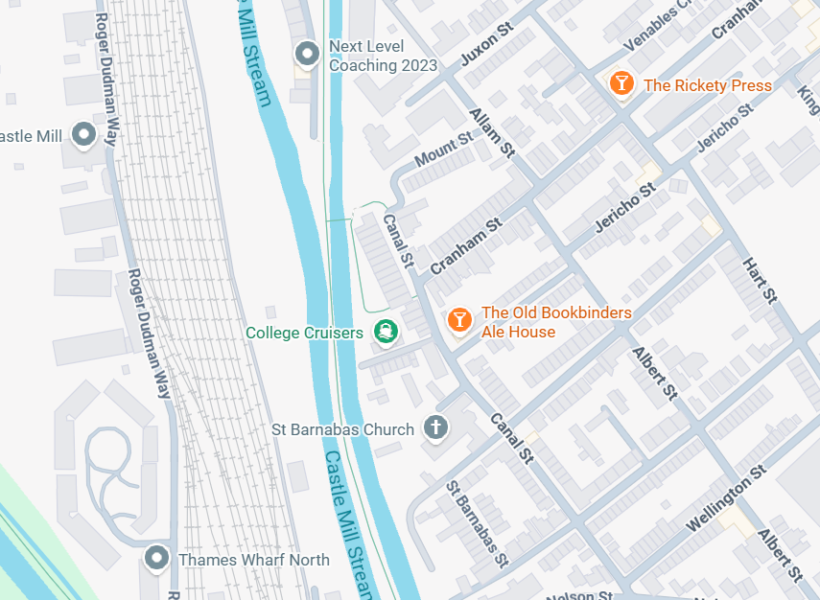
r

